Moving Money with Purpose Investing and Supporting Family Across Borders

Part 3 of 3 IBKR, Wise, remittances, and the household behind the transfers
Brian receives his salary in pounds, sends money to his parents in Kenya, and wants to invest for a future that may involve both countries. Amina earns shillings in Nairobi and wants access to overseas funds. Catherine, now in Dublin, is reviewing the accounts she opened before moving. They are the fictional siblings followed throughout this series, and they face different versions of the same operational question: how does money get from where it is earned to where it is useful? Choosing a fund and arranging its funding are connected parts of the investment decision. The practical work is to match available accounts, supported currencies, and transfer services to each person’s location and purpose. This final article follows those separate functions, using current provider documentation checked on 7 September 2026 and manual calculations that show how fees and exchange rates affect the money delivered.
The starting point is the household’s purpose. Some money needs to reach relatives reliably this month; some needs to remain accessible for emergencies; some can be committed to investment risk for years. Kenya’s mobile-money experience offers an important perspective here. Jack and Suri’s peer-reviewed research connects lower transaction frictions and mobile-money access with households’ ability to receive support and smooth consumption after shocks [1]. The study examines domestic transfers in Kenya, where access to support helps households manage disruption. That household perspective is useful here: financial resilience has value alongside portfolio accumulation. Brian’s remittance arrangement should therefore be judged partly by whether his parents can actually use the money when needed. A route that looks efficient on a fee comparison but regularly creates delays or confusion may be poorly suited to essential support, even if it remains acceptable for an occasional investment contribution.

Decide what the money needs to do
A simple cash allocation makes the competing purposes visible. Suppose Brian takes home £3,000 in a month, spends £1,800 on essential living costs, allocates £400 to agreed family support, and adds £300 to a reserve. That leaves £500 for longer-term investment in this hypothetical budget. The categories are assumptions, not a recommended allocation or a claim about typical diaspora earnings. Their usefulness lies in making commitments explicit before money reaches a brokerage account. If an irregular expense absorbs another £250, the investable amount changes; it should not be preserved mechanically by borrowing or leaving a necessary bill unpaid. Amina can use the same method in shillings. Each household can distinguish a contribution target from a genuine surplus, then decide how much flexibility the investment routine needs. Regular investing works more comfortably when the contribution is supported by the household’s actual cash flow.

Worked calculation 1 Establish an investable surplus
Investable surplus = take-home income − essentials − family support − reserve addition
= £3,000 − £1,800 − £400 − £300
= £500
After an additional £250 essential expense: £500 − £250 = £250
All budget figures are hypothetical monthly amounts.
Remittance costs provide useful context, provided the period and measure are clear. The World Bank’s Remittance Prices Worldwide report for the third quarter of 2025 reports a global average cost of 6.36% for sending $200, compared with 4.59% for digital services and 8.46% for the Sub-Saharan African receiving-region average [2]. These historical service averages combine fees and exchange-rate margins; they are not a quote for Brian’s particular route to Kenya. Applied mechanically, 6.36% of $200 is $12.72, while 4.59% is $9.18. The $3.54 difference illustrates the scale of transfer costs across samples containing different routes and services. Brian can use it as a prompt to examine what he pays on his own route. For an actual decision, Brian needs simultaneous quotes for his amount, funding method, recipient channel, and required arrival time. Aggregate evidence identifies a problem; a comparable live quote helps solve his instance of it.

Worked calculation 2 Interpreting a published average
At the Q3 2025 global average: $200 × 0.0636 = $12.72
At the Q3 2025 digital average: $200 × 0.0459 = $9.18
Illustrative difference: $12.72 − $9.18 = $3.54
These are historical sample averages, not personal quotes or promised savings.

Compare what arrives, using the same starting amount
Consider two hypothetical offers for a total £500 debit. Route A charges a £5 fee and converts the remaining £495 at KES 165 per pound, delivering KES 81,675 before any assumed recipient charge. Route B advertises no fee but converts the full £500 at KES 162, delivering KES 81,000. The route with the visible fee delivers KES 675 more. The delivered amounts give Brian a clear basis for choosing between these two otherwise comparable offers. The comparison only works because the starting debit and recipient outcome are defined consistently. If one quote adds its fee on top of £500 while the other deducts it, they need to be normalised first. Brian should also compare the same payout method and arrival conditions. A bank deposit and a cash collection service can involve different practical costs for the recipient even when the headline conversion looks similar.

Worked calculation 3 Fee plus exchange rate
Recipient KES = (GBP budget − GBP fee) × quoted KES/GBP − recipient KES charge
Assume zero recipient charge for both illustrative routes.
Route A = (£500 − £5) × 165 = 495 × 165 = KES 81,675
Route B = (£500 − £0) × 162 = 500 × 162 = KES 81,000
Difference = 81,675 − 81,000 = KES 675
Using an assumed benchmark of 165 KES/GBP:
Friction-free benchmark = £500 × 165 = KES 82,500
A shortfall = (82,500 − 81,675) ÷ 82,500 = 1.0000%
B shortfall = (82,500 − 81,000) ÷ 82,500 = 1.8182%
The benchmark helps explain the cost, while the delivered amount decides which of these two offers serves the immediate transfer better. A quoted rate can move during the comparison, so a historical central-bank rate is useful context but may not be an executable alternative. The household should preserve the actual quote’s time, total debit, guaranteed or estimated amount, and relevant expiry. It should also identify what happens after delivery: a recipient who must withdraw cash may face a separate charge that another recipient paying a bill electronically would avoid. Cost comparisons are most useful when tied to a particular transfer. A service can be attractive for one amount and route, while another works better for a different destination or urgency. The repeatable skill is to compare the whole transfer under matching assumptions and verify the final amount, rather than memorise a permanent provider ranking.

Eligibility comes before the route diagram
IBKR accepts account applications from Kenya [3], giving Amina a starting point for accessing overseas investments. Her next steps are to complete the application, identify the entity serving her account, and confirm access to the fund and exchange she intends to use. Approval, trading permissions, and deposit methods are determined for the individual account. Once these are in place, she can retrieve the funding instructions and compare the cost of getting money into the account. This sequence gives her concrete information to work with: the investment she can buy, the currency she needs, the beneficiary details, and the payment reference required to identify her deposit. She can then ask her bank for a transfer quote based on those instructions. With the account and route established, future contributions become a routine she can document, cost, and adjust as her income changes.
Wise’s current general eligibility list allows residents of the UK and Ireland to hold money; Kenya is outside that list [4]. Older accounts may have different features, which existing customers can check in their accounts. For Brian, living in the UK, a Wise balance can therefore form part of the funding options he evaluates. Amina, opening accounts as a Kenya resident, needs a route suited to the services available where she lives. Their country of residence explains the difference even though both are Kenyan citizens. A useful account review covers the functions each person needs: holding a balance, receiving account details, sending money, and obtaining a card. Brian can check these against his salary and investment currencies, while Amina can focus on the bank and brokerage services available to her. That gives each sibling a practical starting point for comparing costs and organising transfers.
A direct M-Pesa-to-Wise-to-IBKR funding route is currently unavailable. Wise supports sending money into Kenya in shillings, while KES is unavailable as a general source currency for outgoing transfers [5]. Amina’s practical path begins with the deposit instructions in her brokerage account. She can take those details to her bank and request a quote covering the currency conversion, transfer fee, possible intermediary charges, and expected arrival time. The useful comparison is how many shillings leave her account and how much investment currency reaches the broker. Before sending, she can confirm the beneficiary details and payment reference against the broker’s instructions; after sending, she can match the bank’s confirmation to the credited deposit. Brian can evaluate the supported Wise options available to his UK account alongside bank transfers. Each sibling can then build a repeatable route around the accounts and currencies they use.
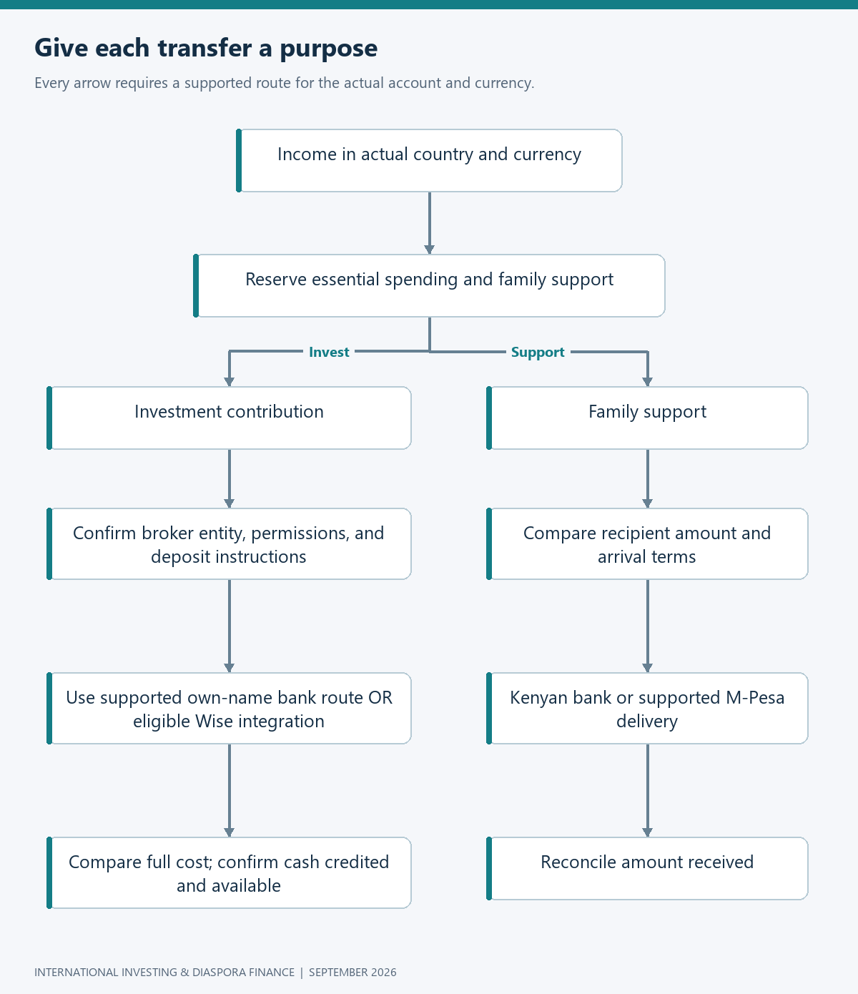
Flowchart: money routes

Fund the brokerage through a documented route
IBKR documents a Wise integration supporting transfers from a Wise balance and bank transfers via Wise, with currencies and methods depending on the account arrangement [6]. For Brian, the starting point is the funding options displayed in his IBKR account. Where Wise is offered and his residence and source currency meet the service requirements, he can follow the account’s instructions to review the transfer. The documented workflow presents the amount, fees, exchange rate, and estimated arrival before confirmation. These details let him compare the proposed transfer with a bank quote on the same basis: total money debited and expected money credited. He can then confirm the linked account details, retain the quote and payment reference, and reconcile the deposit when it arrives. The process gives him both a usable funding route and a record of what that route costs for his contribution size.
Clear ownership details help the broker match an incoming payment to the right customer. IBKR generally discourages and reserves the right to reject third-party deposits, and identifies potential difficulties recognising money sent through payment processors [7]. The straightforward funding arrangement uses the account holder’s own bank account or a supported integration, following the instructions supplied by the broker. Brian can keep the sender name, beneficiary details, payment reference, and transfer confirmation together so that a deposit can be traced if necessary. Where a relative contributes money, the family can first agree who will own the investment and confirm an accepted funding arrangement with the institutions involved. Once the payment is sent, checking both the sending confirmation and the brokerage credit closes the record. This small administrative habit makes subsequent transfers easier to reconcile and gives customer support useful information when a payment needs attention.
Foreign-exchange pricing inside the broker deserves its own calculation. IBKR’s first published manual spot-currency tier is 0.20 basis points of trade value with a $2 minimum; its automatic conversion service typically adjusts the exchange rate by 0.03% without a separate commission [8]. One basis point is 0.01%, so 0.20 basis points equals 0.002%, not 0.20%. On a $500 equivalent conversion, the proportional manual charge is only one cent, but the $2 minimum applies. The automatic adjustment component would be fifteen cents at the stated typical rate. These are comparisons of published charging components, excluding market spread, execution differences, eligibility, and any additional account-specific charges. They show why the lowest percentage does not necessarily produce the lowest charge for a small transaction. The actual decision should use the available account route and the quote provided when the conversion is made.

Worked calculation 4 A minimum fee changes the comparison
Manual component Cₘ = max($2, A × 0.00002)
Automatic component Cₐ = A × 0.0003
A = USD-equivalent conversion amount.
At A = $500:
Cₘ = max($2, $0.01) = $2; $2 ÷ $500 = 0.40%
Cₐ = $500 × 0.0003 = $0.15; $0.15 ÷ $500 = 0.03%
At A = $10,000:
Cₘ = max($2, $0.20) = $2; $2 ÷ $10,000 = 0.02%
Cₐ = $10,000 × 0.0003 = $3; $3 ÷ $10,000 = 0.03%
The crossover is approximately $6,666.67 while the manual minimum remains binding: divide $2 by 0.0003. Above that amount, the manual charge component becomes smaller than the assumed automatic component; below it, the reverse holds in this simplified comparison. The proportional manual fee only overtakes its $2 minimum at $100,000. These thresholds are useful arithmetic, but they do not prescribe an account action on their own. A different spread, additional intermediary fee, or unavailable conversion method can change the practical result. The household should also resist converting currencies merely because a calculation identifies a cheap route. If the money is already in a currency suited to the intended transaction, an unnecessary extra conversion adds another decision and potential cost. The purpose of understanding the schedule is to reduce avoidable friction on necessary transactions, rather than turning household investing into a separate currency-trading activity.

Worked calculation 5 Charge-component thresholds
Crossover while manual minimum binds: $2 = A × 0.0003
A = $2 ÷ 0.0003 = $6,666.67
Manual proportional fee equals minimum: $2 = A × 0.00002
A = $2 ÷ 0.00002 = $100,000
Actual all-in execution can differ from this charge-only comparison.

Small transfers make fixed costs visible
The funding decision should combine all relevant stages in one currency. Suppose an investor starts with the equivalent of $1,000 and an illustrative route incurs $12 in bank and transfer charges, $3 in conversion friction, and $1 in dealing commission. That leaves $984 exposed to the investment, before the separate effect of the purchase spread. A second route charging only $4 for transfer but $15 for conversion and the same $1 commission leaves $980. The cheaper transfer fee has produced less invested money. This example is deliberately hypothetical and assumes each cost is separately measured without double-counting. If an exchange-rate margin is already included in a quoted delivered amount, it should not be deducted again. Amina can build the same comparison from her bank’s debit and the broker’s credited amount, then add the actual purchase cost. The result connects a funding route to the investment it ultimately enables.

Worked calculation 6 Follow the whole funding cost
Investable amount before purchase spread = initial equivalent − transfer − FX − dealing
Route A = $1,000 − $12 − $3 − $1 = $984
Route B = $1,000 − $4 − $15 − $1 = $980
Difference = $984 − $980 = $4
Route A measured charges = $16 ÷ $1,000 = 1.6%
Route B measured charges = $20 ÷ $1,000 = 2.0%
Illustrative charges only; do not deduct an embedded FX margin twice.
Batching contributions can reduce fixed costs, although waiting has its own consequences. Imagine a household accumulating $500 each month and paying a hypothetical $20 fixed funding charge per transfer. Twelve monthly transfers cost $240 annually, while four quarterly transfers cost $80, saving $160 before other differences. Under a convention where each contribution is available at month-end and quarterly transfers occur at the third month-end, the average delay is one month: the first contribution waits two months, the second one, and the third none. At a purely illustrative 6% annual expected return and zero return on waiting cash, a simple opportunity-cost estimate on the $6,000 annual contributions is about $30. The arithmetic favours batching under those assumptions. It does not guarantee that waiting is better in a particular year, because actual market returns during the waiting periods can be positive or negative.

Worked calculation 7 Batching with an explicit timing assumption
Monthly fixed costs = 12 × $20 = $240
Quarterly fixed costs = 4 × $20 = $80
Fixed-cost saving = $240 − $80 = $160
Average waiting time within each quarter = (2 + 1 + 0) ÷ 3 = 1 month
Simple expected opportunity cost = annual contributions × return × delay in years
= $6,000 × 0.06 × (1 ÷ 12) = $30
Illustrative net advantage = $160 − $30 = $130
Assumes zero waiting-cash return, stable charges, and no other timing differences.
The sensible batching rule depends on contribution size and the actual fixed charge. If the fee were much smaller, the saving could be outweighed by the inconvenience of accumulating cash or by a preference for a simpler monthly habit. If waiting cash earns interest, the opportunity-cost estimate should use the difference between the investment return assumption and that cash return. A household with volatile earnings may value flexibility more than a rigid calendar. The important distinction is between predictable funding economies and speculative market timing. Brian can choose a schedule because it keeps costs proportionate, then follow it without trying to forecast the next market dip. He can review the schedule when his contribution changes materially or the provider changes its charges. A rule tied to observable costs and income is easier to explain and maintain than a series of improvised decisions based on short-term price movements.
Once money arrives at the broker, the final purchase still requires a check. The investor should confirm the correct instrument, exchange, trading currency, available cash, estimated commission, and order conditions before submitting. A displayed account value is not necessarily the same as cash available for the planned action, and account types can treat currency balances and borrowing differently. Amina’s intention is to invest her own surplus, so she should verify that the proposed order accomplishes that intention without inadvertently introducing borrowing. The trade confirmation then belongs beside the funding record, connecting money sent with assets acquired. This completes the loop that began with the household budget. It also prevents a common accounting gap: recording the amount transferred as the amount invested, even when some remains as cash or has been consumed by charges. A small reconciliation after each purchase can keep the long-term record reliable.

Keep the remittance route usable at the receiving end
Wise documents KES delivery to Kenyan bank accounts and M-Pesa wallets, with route-specific limits and timing conditions [9]. That gives an eligible sender such as Brian a choice of receiving channels, but the choice should begin with how his parents intend to use the funds. A bank account may suit a larger planned expense, while a mobile wallet may be convenient for everyday payments. The recipient’s actual access, withdrawal costs, identification details, and payment habits belong in the decision. A service’s estimated arrival time also needs to be read in context: the clock may depend on receipt of the sender’s funds and completion of conversion. Brian should arrange essential payments with enough room for those stages, especially around weekends or holidays. The aim is a dependable household routine in which the recipient knows what is coming and can confirm that the delivered amount matches the agreed purpose.
When a transfer is delayed, a clear record is more useful than repeatedly sending another payment through the same uncertain route. The household can identify the stage reached: was the sender debited, did the service receive the money, has conversion completed, was the recipient institution paid, and can the recipient see the credit? The transaction reference and expected amount help each institution investigate the correct payment. A separate emergency channel can keep a medical or household need from depending entirely on that investigation, but it should be used with awareness of the original payment’s status to avoid accidental duplication. A shared record of these stages gives the sender and recipient a clear way to coordinate while the institutions investigate the payment. Reliability improves when the household knows who should act at each stage and retains the evidence needed to explain the problem clearly.
For travel and everyday spending, card access deserves its own place in the household plan. Wise’s current issuance list includes the UK and EEA but not Kenya [10]. Its usage documentation also distinguishes issuing countries: US-issued Wise cards currently list Kenya among locations where use is restricted, while the cited non-US restrictions differ [11]. For a UK- or EEA-issued card, the practical checks are the issuer’s current usage terms, the account’s status, and acceptance at the intended merchant or cash machine. Catherine should identify her actual card issuer and review the current terms before relying on it for a trip. The lesson applies beyond Wise: the ability to hold a balance, order a card, use that card abroad, and replace it after moving are different questions. A backup payment method is a practical response when essential spending depends on an account whose features may change across borders.
Moving country is a useful moment to review how salary, bills, remittances, and investment contributions will continue during the transition. Wise’s residence-change guidance asks customers to update their details and provide supporting evidence, and describes restrictions while the change is reviewed [12]. Separately, its card guidance explains circumstances in which an existing activated card can remain usable until expiry after moving to an unsupported country, without local replacement availability [10]. For Catherine, the practical plan is to update her residence, check which balance and card features will be available at her new address, and keep enough accessible money elsewhere to cover the review period. She can also note her card’s expiry date and arrange a replacement payment method where needed. The objective is continuity: essential payments keep moving while she settles into the services available in her new country.

Family finance needs an agreement as well as an app
The reserve can be calculated around commitments rather than a generic slogan. Suppose Brian has £400 of monthly family support that he wants to protect against a temporary interruption in earnings or account access. A three-month support reserve would be £1,200, separate from his own living-cost buffer. That is an illustrative policy choice, not a universally sufficient amount. He can refine it by considering medical needs, other relatives’ contributions, and how quickly alternative income might become available. If the obligation is fixed in shillings, he should also test exchange-rate changes rather than assuming a constant sterling cost. The family can decide how much belongs in an immediately usable Kenyan channel and how much can remain elsewhere. The resulting arrangement gives the reserve a defined job. It also makes clear why money allocated to an essential near-term payment should not silently become part of a long-horizon equity contribution.

Worked calculation 8 A support reserve and currency stress
Three-month reserve for an assumed £400 monthly commitment = 3 × £400 = £1,200
For a fixed KES 66,000 obligation, excluding fees:
At 165 KES/GBP: KES 66,000 ÷ 165 = £400
At 150 KES/GBP: KES 66,000 ÷ 150 = £440
Additional sterling needed = £440 − £400 = £40 = 10% of £400
Exchange rates are hypothetical stress assumptions.
Agreeing the intended use of a remittance can also improve the quality of the financial conversation. Ambler, Aycinena, and Yang’s field experiment with migrants from El Salvador examined a programme that subsidised designated education remittances and found changes in educational outcomes and spending [13]. The findings concern that programme’s education focus and subsidy design. For Brian’s household, they offer a useful starting point for discussing what a transfer is meant to achieve and reviewing the outcome with the recipient. A school-fee contribution, routine household support, and a capital investment in a family business involve different expectations. Brian can be clear about what he can sustain, while his parents can explain their priorities and changing needs. The payment technology makes the transfer possible, but mutual understanding determines whether the arrangement actually serves the people involved.
Joint planning also deserves attention within the household sending the money. Seshan and Yang’s study of Indian migrant households linked a financial-education intervention to greater joint financial decision-making, with financial outcomes varying across participants [14]. The outcomes reflect the participants and intervention studied. For Kenyan diaspora households considering their own arrangements, the research offers a reason to explore how shared information and regular discussion can support financial decisions. In Brian’s household, the discussion can connect remittances, reserves, investment contributions, and a possible return to Kenya. A shared monthly review can identify whether support commitments are rising, whether an investment goal is still realistic, and which expenses require advance notice. The purpose is to make obligations visible and negotiable. A portfolio statement may belong to one account holder, but the choices behind it can affect several people whose expectations deserve to be understood.

Reconcile the money, then review the plan
A portfolio balance can grow because investments performed well, because the owner contributed more, or both. It can fall because markets declined, because money was withdrawn for a useful purpose, or because of charges. The household should therefore reconcile cash flows before judging performance. In a simplified example, an account starts at $10,000, receives $2,000, pays out $500, and ends at $12,100. Its net investment profit is $600 after the effects already reflected in that closing balance. Dividing by the opening balance alone does not produce a properly time-adjusted return when flows occurred during the period. For a reliable performance percentage, timing needs to be incorporated through an appropriate return calculation. The elementary reconciliation below serves a narrower job: separating money added and removed from the economic change inside the account. That separation helps the household see how saving effort and investment performance each contributed to the closing balance.

Worked calculation 9 Separate flows from profit
Net investment profit = ending value − starting value − contributions + withdrawals
= $12,100 − $10,000 − $2,000 + $500
= $600
This is profit in dollars, not a time-weighted or money-weighted return percentage.
Assumes consistent valuation currency and complete cash-flow records.
The same discipline applies when the household eventually draws on its investments. Selling an ETF, receiving available cash, converting currency, withdrawing from the broker, and delivering money to a Kenyan recipient are separate stages. Their timing and charges should be checked before an important payment depends on them. The flowchart below brings together the investment and household records: the sale creates an investment event, the conversion creates a currency transaction, and the withdrawal creates a cash flow. Part 2’s tax analysis belongs alongside those steps, including any relevant gain calculation or reporting adjustment. Planning the withdrawal sequence in advance gives the household a clearer view of how much usable money will arrive. The household can then work backwards from the recipient’s payment deadline, allowing time for each stage and keeping an accessible reserve for needs that arise sooner.
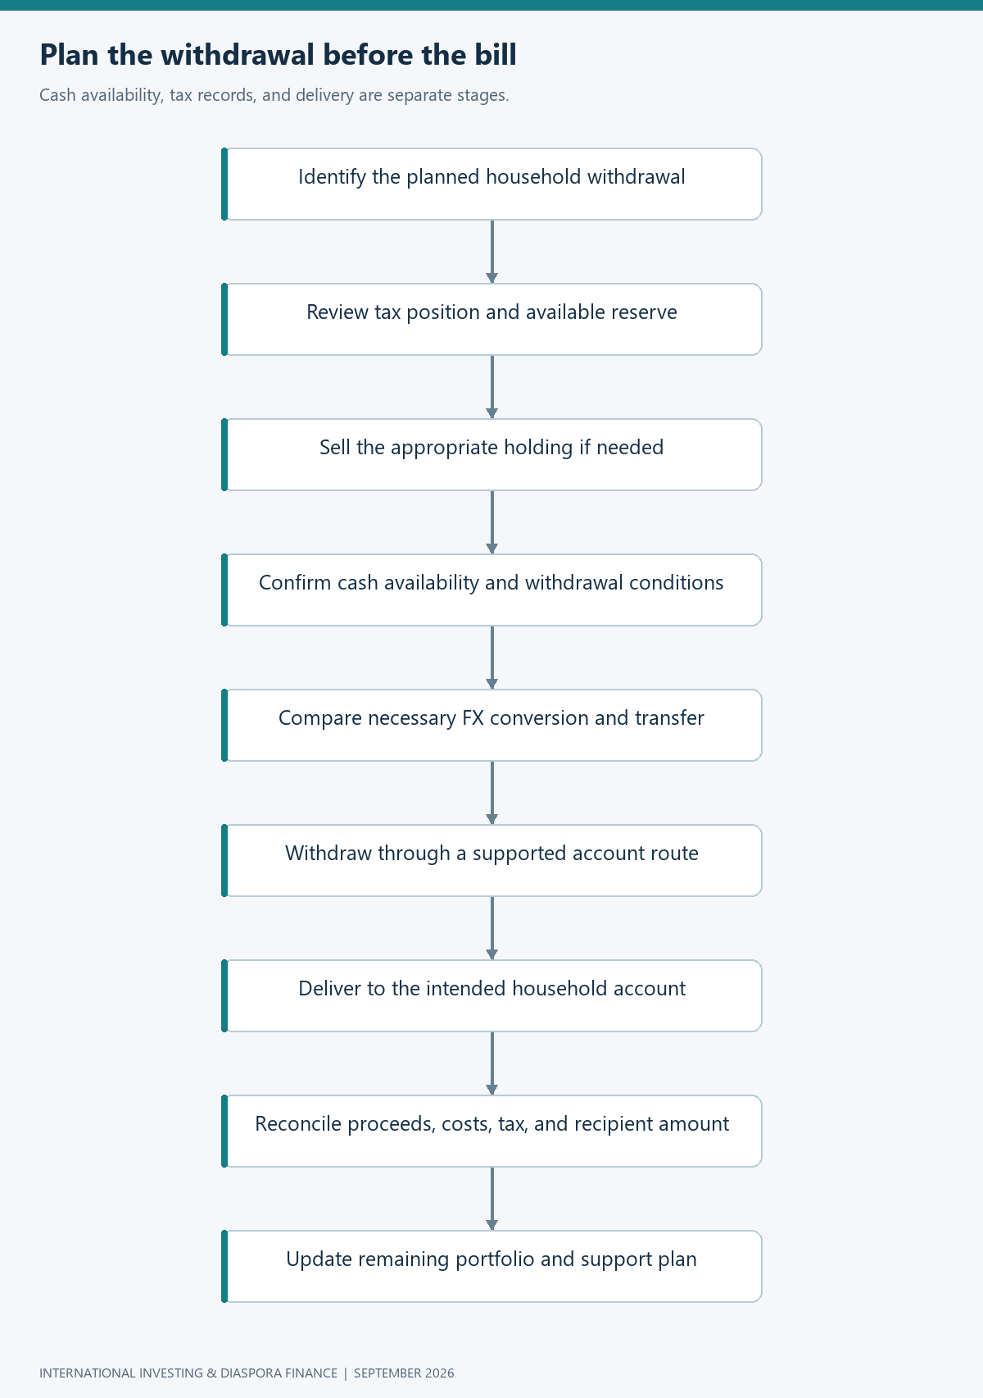
Flowchart: withdrawal sequence
The siblings finish with a system they can explain in ordinary language. They know what they own, which residence rules need attention, which account services are available to them, and how to compare the money that reaches an investment or a family member. The system includes room for uncertainty: market returns vary, exchange rates move, and provider features change. Its strength comes from a few repeatable habits—define the purpose, verify the route, compare the total result, retain the evidence, and review when circumstances change. For Brian, success can mean both a growing long-term portfolio and dependable support at home. For Amina, it can mean overseas exposure acquired through a workable route at a proportionate cost. For Catherine, it can mean continuity through relocation without losing track of tax or access. International finance becomes more useful when its moving parts serve a clearly understood household plan.

References
[1] W. Jack and T. Suri, “Risk sharing and transactions costs: Evidence from Kenya’s mobile money revolution,” American Economic Review, vol. 104, no. 1, pp. 183–223, 2014, doi: 10.1257/aer.104.1.183.
[2] World Bank, “Remittance Prices Worldwide,” issue 54, Q3 2025, report hosted Apr. 2026. [Online]. Available: Q3 2025 report. Accessed: Sep. 7, 2026.
[3] Interactive Brokers, “Available countries and territories,” n.d. [Online]. Available: account country list. Accessed: Sep. 7, 2026.
[4] Wise, “Where do I need to live to hold money with Wise?” n.d. [Online]. Available: balance eligibility. Accessed: Sep. 7, 2026.
[5] Wise, “What currencies can I send to and from?” n.d. [Online]. Available: currency support. Accessed: Sep. 7, 2026.
[6] Interactive Brokers, “Transfer from Wise balance,” updated Apr. 27, 2026. [Online]. Available: integration guide. Accessed: Sep. 7, 2026.
[7] Interactive Brokers, “USD deposits and withdrawals,” n.d. [Online]. Available: funding guidance. Accessed: Sep. 7, 2026.
[8] Interactive Brokers, “Commissions spot currencies,” n.d. [Online]. Available: FX schedule. Accessed: Sep. 7, 2026.
[9] Wise, “Guide to KES transfers,” n.d. [Online]. Available: Kenyan delivery guide. Accessed: Sep. 7, 2026.
[10] Wise, “Can I get the Wise card in my country?” n.d. [Online]. Available: card eligibility. Accessed: Sep. 7, 2026.
[11] Wise, “Where will my Wise card work?” n.d. [Online]. Available: card usage restrictions. Accessed: Sep. 7, 2026.
[12] Wise, “How do I update my country of residence?” n.d. [Online]. Available: residence-change guide. Accessed: Sep. 7, 2026.
[13] K. Ambler, D. Aycinena, and D. Yang, “Channeling remittances to education: A field experiment among migrants from El Salvador,” American Economic Journal: Applied Economics, vol. 7, no. 2, pp. 207–232, 2015, doi: 10.1257/app.20140010.
[14] G. Seshan and D. Yang, “Motivating migrants: A field experiment on financial decision-making in transnational households,” Journal of Development Economics, vol. 108, pp. 119–127, 2014, doi: 10.1016/j.jdeveco.2014.01.005.

